Practical - 1

Task - 1:
Compilation and Execution:
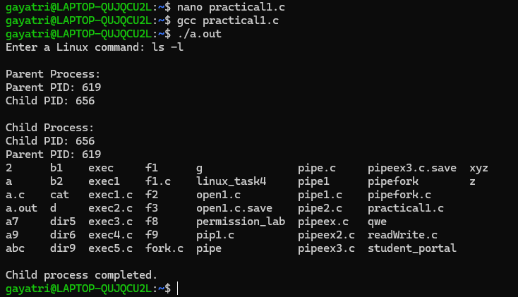

Task 2:
- uname:
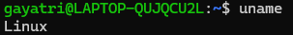
- lscpu:
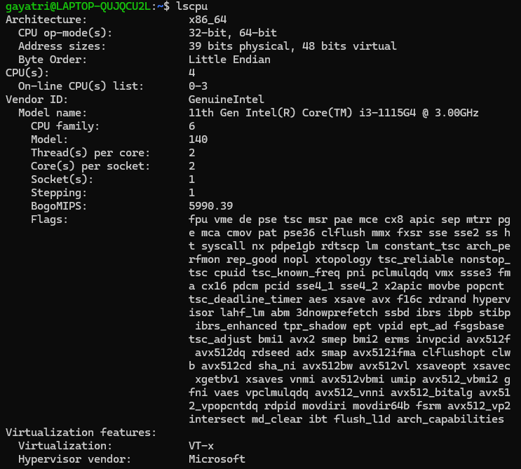
- lsblk:
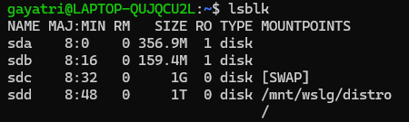
- ps:
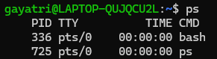
- top:
